Unit 5 The Internet, WWW and E-mail

The internet is a collection of a large number of computers connected together all over the world. By using internet we can look up information on any subject or send and receive messages through email. But we have to be careful about our safety while using the internet.

In this unit, we will also discuss the World Wide Web – the fastest growing area of the internet made up of millions of websites and E-mail, which is the exchange of messages by telecommunication.

**Learning Objectives**

After completing this unit, students will be able to

* Define Internet
* Connect to internet
* Know about internet safety
* Know the world wide web
* Know the web page address
* Know different web browsers
* Know the search engines
* Use different search engines to search data
* Use online maps to locate your city/school
* Use Google Translator
* Define email, account, username and password
* Know about Gmail
* Create email account and sign-in
* Recognize To:, Subject:, CC:, Attach file:
* Compose and send email
* Use the folders Inbox, Sent, Drafts
* Check and reply Email
* Sign out

# 5.1 Introduction to the Internet

Today we live in a world of technology, where internet spins a web of interconnectivity around the globe. Through [internet](https://www.informationq.com/what-is-internet/) billions of people around the world have been connected. Internet was evolved in 1969, under the project called **ARPANET** (Advanced Research Projects Agency Network) to connect computers at different universities and U.S. defense. Soon after, the people from different backgrounds such as engineers, scientists, students and researchers started using the network for exchanging information and messages.

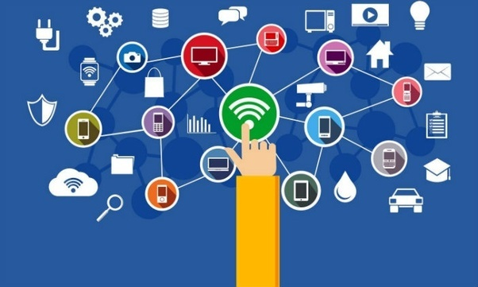

Figure 5.1 Introduction to internet

**5.1.1 Internet**

**Internet** is a global network of computer networks. It comprises of millions of computing devices that carry and transfer volumes of information from one device to the other. Desktop computers, mainframes, GPS units, cell phones, car alarms, video game consoles are connected to the internet.

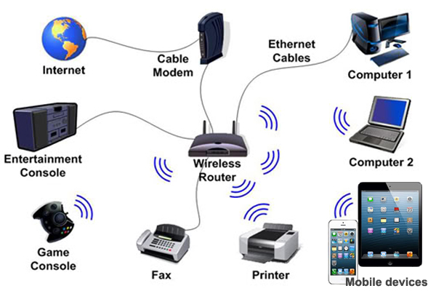

Figure 5.1.1 (a) Computing Devices

A **network** is a system of interconnected computers that communicate with one another and share application, data and hardware components.

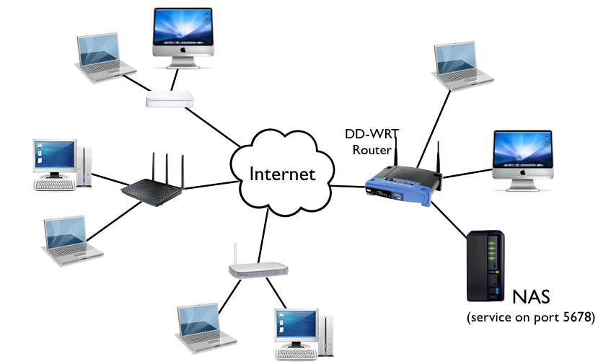

Figure 5.1.1 (b) A network example

DO YOU KNOW?

The new 2018 Global Digital suite of reports reveal that there are now more than 4 billion people around the world using the internet.



.

DO YOU KNOW?

**National Response Centre for Cyber Crime (NR3C)** - FIA is a law enforcement agency dedicated to fight cyber crime in Pakistan. Inception of this Hi-Tech crime fighting unit transpired in 2007 to identify and curb the phenomenon of technological abuse in society

.

**5.1.2 Connecting to Internet**

* **Types of Internet Connection**

When a user wants to access internet, first of all he/she has to establish a connection of the computer to the internet. The connection is provided by a company which is known as **Internet Service Provider (ISP).** These connections can be wired or wireless.These ISPs offer different types of connections.

* **Telephone (dialup) modem**

**Dial-up connection** is a technology that helps a user to connect to the internet using standard phone lines. A user can access internet by plugging in telephone line in the modem. It is a slow speed and inexpensive technology. In this type of connection, telephone line remains busy and one cannot make any calls.

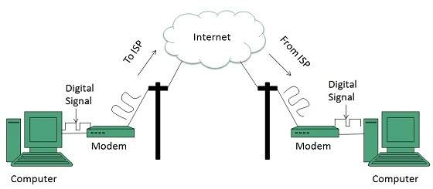

Figure 5.1.2 (a) Dialup Modem Setup

* + **Broadband**

Broadband Internet service truly is the most used form of Internet access because of its high access speeds. It is offered in four different forms

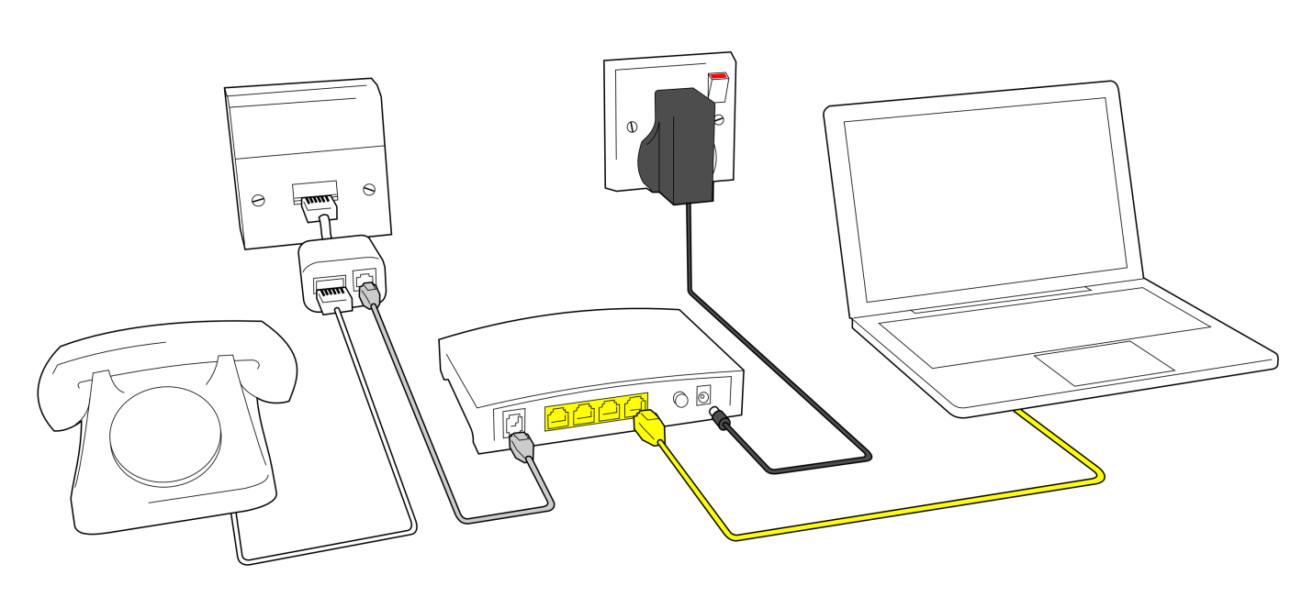 Figure 5.1.2 (b) Broadband Modem Setup

* **DSL (Digital Subscriber Line)**

**DSL** is a high speed internet technology that runs over standard phone lines. It is one of the fastest and most affordable types of internet connection. A DSL modem is connected to the computer with a network card. In DSL connection, telephone lines remain free to make calls.

* **Cable Modem**

**Cable modem service** is a technology that helps users in connecting to the internet using their cable TV wire. It provides a high speed connection as compared to the dial-up modems. It provides an “always ON” connection. It means that whenever a computer is powered on, the connection is ON. Cable modem can be connected to the computer with the network card.

* **Satellite**

Satellite accesses the internet via a satellite in Earth’s orbit. The enormous distance that a signal has to cover in travelling from earth to satellite and back again, provides a delayed connection as compared to the cable and DSL.

* **Fiber Optic**

The newest broadband service is **fiber-optic**, which is the fastest Internet connection thus far. However, this type of Internet service is still in its infancy as its service areas are quite limited and because the laying down of the fiber-optic cable takes a while to complete. Wherever it is available, the cost not only competes with that of DSL and cable, but it provides a much faster connection than both of those services.

DO YOU KNOW?

The $44 million **Optical Fiber Cable (OFC) project**, directly connecting Pakistan and China would be completed under the China Pakistan Economic Corridor (CPEC) by December 31, 2018, providing safest internet route to both countries.



.

* **Wireless**

**Wireless**, or **Wi-Fi**, as the name suggests, does not use telephone lines or cables to connect to the internet. Instead, it uses radio frequency. Wireless is also an always on connection and it can be accessed from just about anywhere.

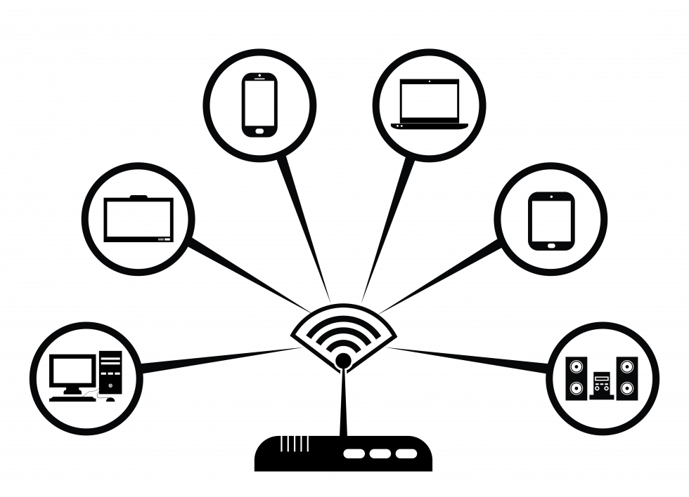

Figure 5.2.2 (c) Wifi

* **Cellular**

**Cellular technology** provides wireless Internet access through cell phones. The speeds vary depending on the provider, but the most common are 3G and 4G speeds.  A **3G** is a term that describes a 3rd generation cellular network obtaining mobile speeds of around 2.0 Mbps. **4G** is the fourth generation of cellular wireless standards. The goal of 4G is to achieve peak mobile speeds of 100 Mbps but the reality is about 21 Mbps currently.

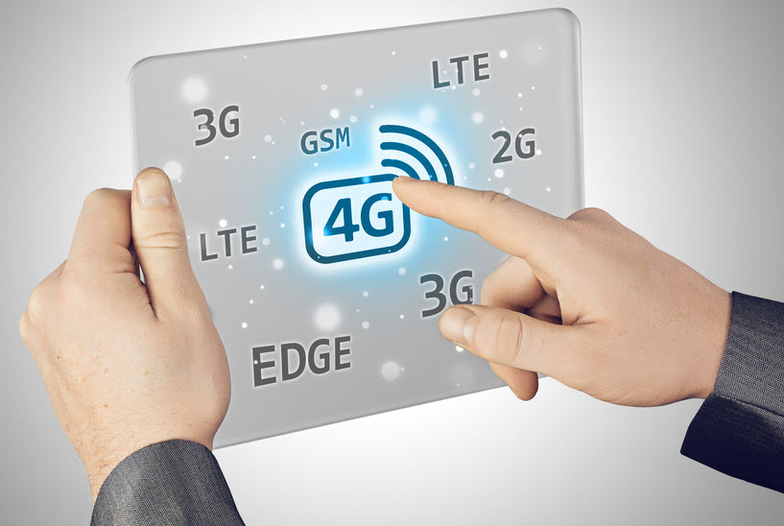

Figure 5.1.2 (d) Cellular Technology

DO YOU KNOW?

The number of 3G and 4G users in Pakistan has reached 53.24 million by the end of March 2018, according to the Pakistan Telecommunication Authority (PTA). 

.

* + - **Requirements for Connecting to the Internet**

Following are the requirements for connecting to the internet.

1. **Computer**

A computer, tablet or a cell phone is an essential part for assessing the internet. We cannot access the internet without one of these devices.

1. **Modem**

A **modem** is a device which is used to connect and communicate with other computers.

* **Internal Modems**

An **internal modem** is a network device that is contained on an expansion board that plugs into the motherboard. Unlike an external modem, an internal modem contains no lights to inform the user of its current function or changing modem states. Internal modems are also known as on-board modems. Dial-up connection is an example of internal modem.

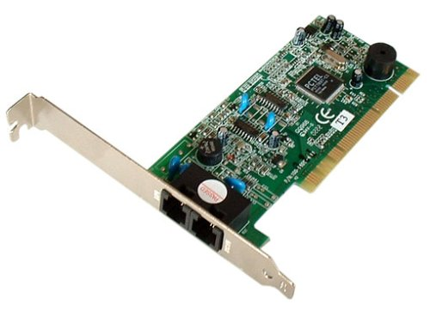

Figure 5.1.2 (e) Internal Modem

* **External Modems**

An **external modem** is similar to the internal modem in that it also allows access to the Internet, but unlike the internal modem, the external modem sits outside the computer

External modems have lights indicating various modem functions and they can easily be moved from one computer system to another. They do, however, require one COM or USB port to operate. Examples are DSL and cable modems.

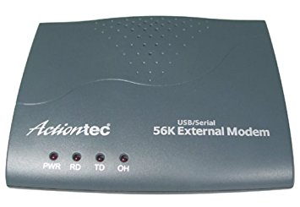

**Figure 5.1.2 (f) External Modem**

1. **Telephone / Cable TV Line**

A telephone line is required for a DSL or Dialup connection whereas a cable TV line is required for cable modem connections.

1. **Internet Service Provider (ISP)**

A company that provides an internet connection is known as **Internet Service Provider (ISP)**. Some of the leading ISPs in Pakistan are:

* PTCL (Pakistan Telecommunication Limited)
* Wi-tribe
* COMSATS Internet Services
* Qubee
* Wateen

1. **Web Browser**

A **Web browser** is a software which is used to access and view different websites. Mozilla Firefox, Google Chrome, Safari, Microsoft Internet Explorer are some famous web browsers.



**Figure 5.1.2 (g) Web Browsers**

# 5.2 World Wide Web (The Web)



**Figure 5.2 World Wide Web**

History of World Wide Web

The [World Wide Web](https://www.informationq.com/about-the-world-wide-web-and-identifying-a-hyperlink/) was invented by Tim Berners-Lee in 1989. He wrote the first [web browser](https://en.wikipedia.org/wiki/Web_browser) in 1990 while employed at [CERN](https://en.wikipedia.org/wiki/CERN) in Switzerland. The browser was released outside CERN in 1991, first to other research institutions starting in January 1991 and to the general public on the Internet in August 1991.

Since that time, the web has changed the world. It has perhaps become the most powerful communication medium the world has ever known.

DO YOU KNOW?

Internet and Web is not the same thing: Web uses internet to pass over the information to the users.



.

**5.2.1 Definition of World Wide Web**

## The World Wide Web is part of the Internet. It is a collection of millions of pages of information. This information can include texts, pictures, animations, sounds and video, and it can be about anything. In simple terms, The World Wide Web is a way of exchanging information between computers on the Internet.

**5.2.2 Web Page Address**

**Web page** is a document available on World Wide Web. A web page can contain huge information including text, graphics, audio, video and hyper links. **Hyper links** are the link to other web pages. Web Pages are stored on web server and can be viewed using a web browser. A **website** is a collection of related web pages.

**URL (Uniform Resource Locator)** is the address of a webpage on the internet. Every web page has a unique address. A webpage can only be accessed if we know the URL of that page. For example Google is one of the most popular websites and its URL is <https://www.google.com/>

DO YOU KNOW?

If you look at the address bar you will notice that for some websites URL begins with “*http://*” whereas for others it starts with “*https://*” The main difference between these two is that http:// is considered to be unsecure while https:// is considered to be secure.

.

**5.2.3 Web Browser**

**Web Browser** is a software that is used to access the World Wide Web. We can access and view different web pages or websites using a web browser. A good web browser is user friendly. We can type the URL of any website in its address bar and the browser will show that particular website. Some popular web browsers are:

* Mozilla Firefox
* Google Chrome
* Opera
* Safari
* Microsoft Edge
* Microsoft Internet Explorer

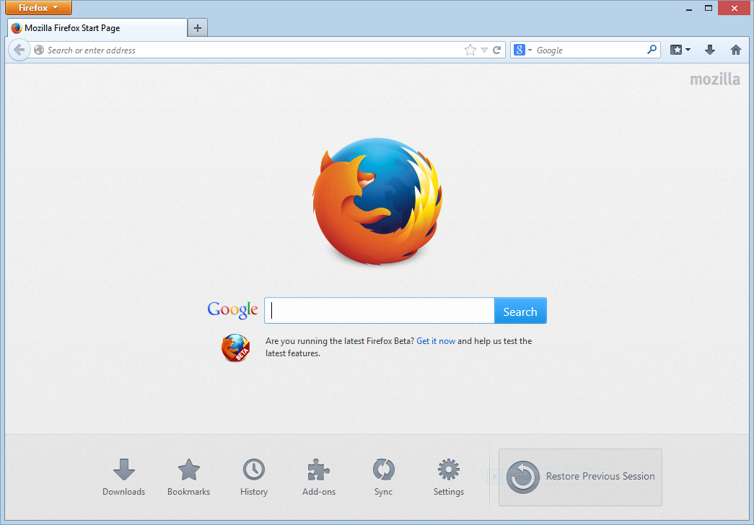 **Figure 5.2.3 (a) Mozilla Firefox**

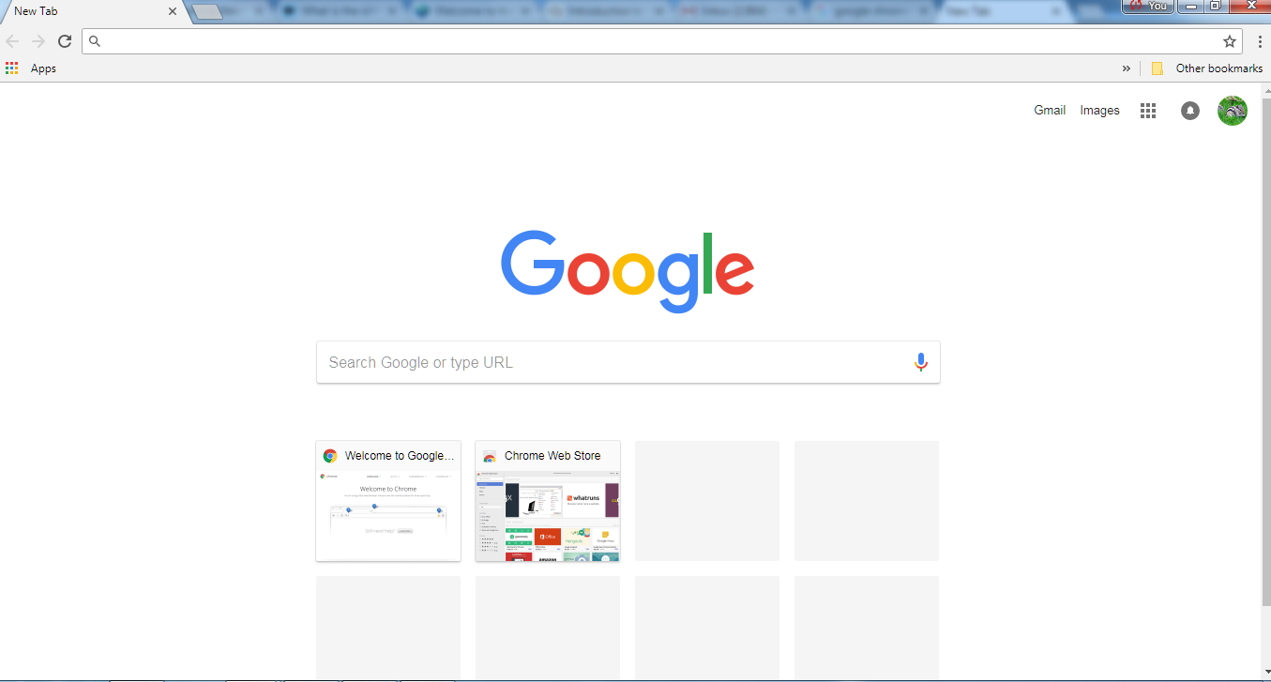 **Figure 5.2.3 (b) Google Chrome**

* **Accessing Different Web Pages using Internet Explorer**
* Open Internet Explorer by clicking on the Internet Explorer icon in the *taskbar*.

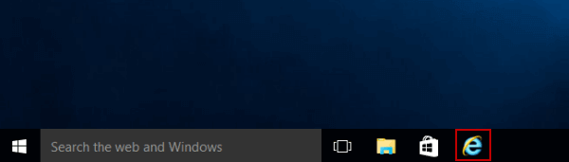**Figure 5.2.3 (c) Internet Explorer icon**

* Type the URL [www.google.com](http://www.google.com) in the address bar.

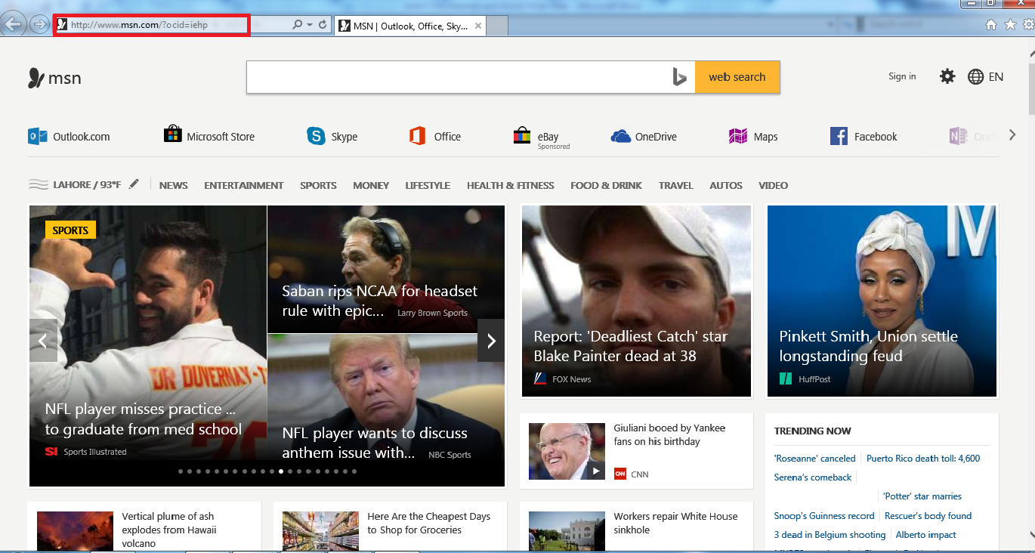 **Figure 5.2.3 (d) Write URL in address bar**

* Press Enter key.
* The home webpage of Google website will appear.

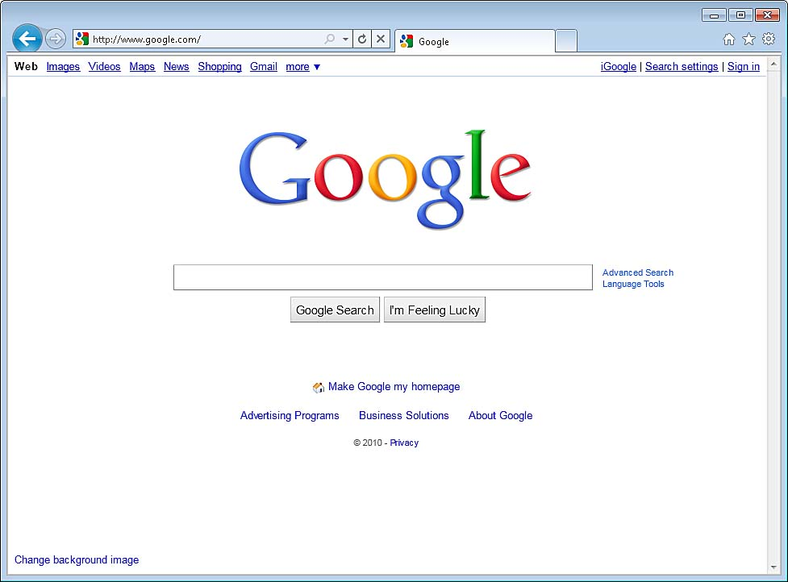**Figure 5.2.3 (e) Internet Explorer (Google)**

Try It Yourself!

* Open Internet Explorer
* Now one by one type the following addresses

in the address bar.

* + [www.yahoo.com](http://www.yahoo.com)
  + [www.typingtutor.org](http://www.typingtutor.org)
  + [www.w3schools.com](http://www.w3schools.com)
  + [www.wikipedia.org](http://www.wikipedia.org)
  + [www.wikihow.com](http://www.wikihow.com)



**5.2.4 Search Engines**

**Search Engine** is a program that is used to find web pages and websites on the internet. When we type a word or a phrase, the search engine will show a list of websites with related information. Some of the most popular search engines are listed below

* Google ([www.google.com](http://www.google.com))
* Yahoo ([www.yahoo.com](http://www.yahoo.com))
* Ask ([www.ask.com](http://www.ask.com))
* Bing ([www.bing.com](http://www.bing.com))
* MSN ([www.msn.com](http://www.msn.com))

Web search engines work with the help of two programs, **Spider** which fetches as many documents as possible. Another program, called an **indexer**, reads the documents and creates an index based on the words contained in each document. Each search engine uses an algorithm to create its indices such that, only related results for specified keywords is stored and returns a list of the documents where the keywords were found.

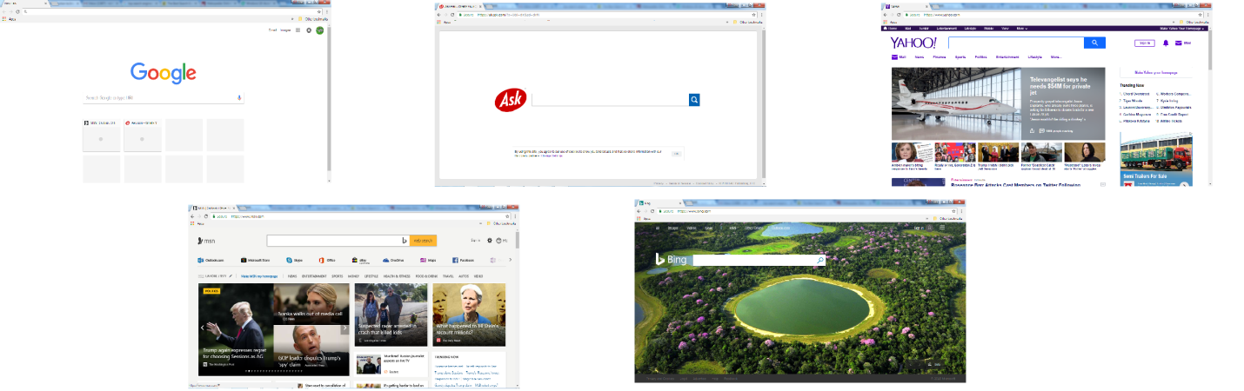 **Figure 5.2.4 (a) Search engines**

* + - **Using Search Engines**

Using Google

* Open Internet Explorer, Google Chrome or any other web browser installed on your computer.
* The *home page* of the browser will open. By default the home page of *Google Chrome* is set to *Google Search.*

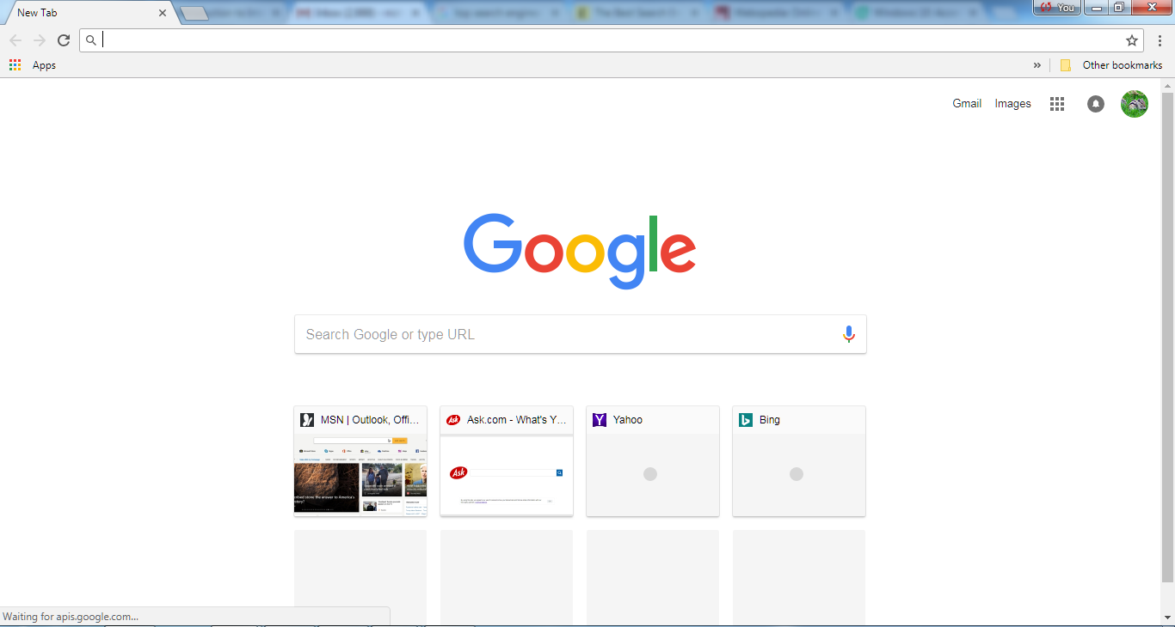 **Figure 5.2.4 (b) Google Search engine**

* Type “Pakistan news” in the search bar and press Enter.
* List of related web pages or websites will appear.

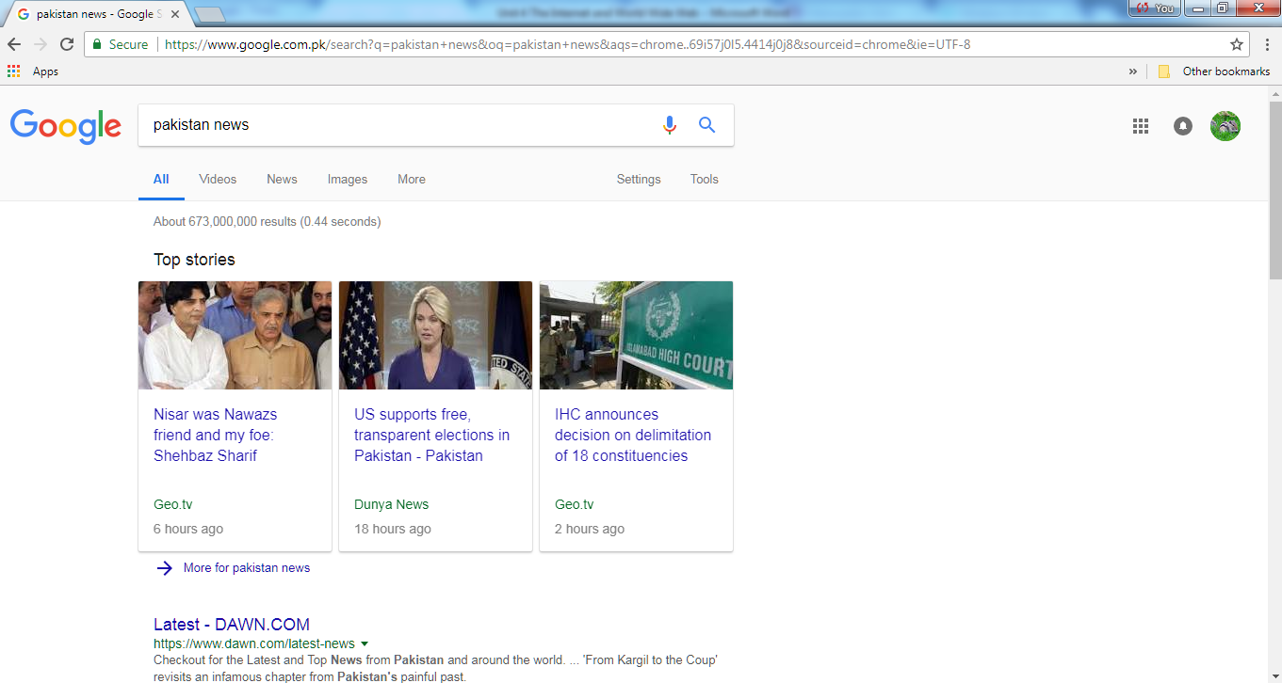 **Figure 5.2.4 (c) list of related results**

Using Yahoo

* Open Internet Explorer, Google Chrome or any other web browser installed on your computer.
* The *home page* of the browser will open. By default the home page of *Google Chrome* is set to *Google Search.*
* Type the URL [www.yahoo.com](http://www.yahoo.com) in the address bar and press Enter.
* Yahoo home page will appear.

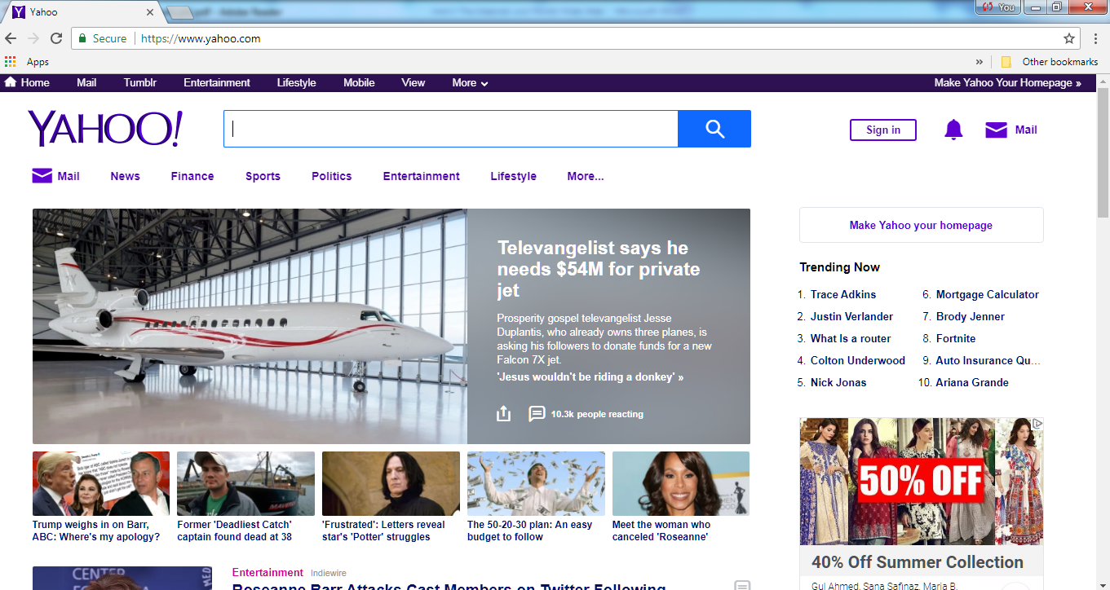**Figure 5.2.4 (d) Yahoo Search engine**

* Type “Pakistan news” in the search bar and press Enter.
* List of related web pages or websites will appear.

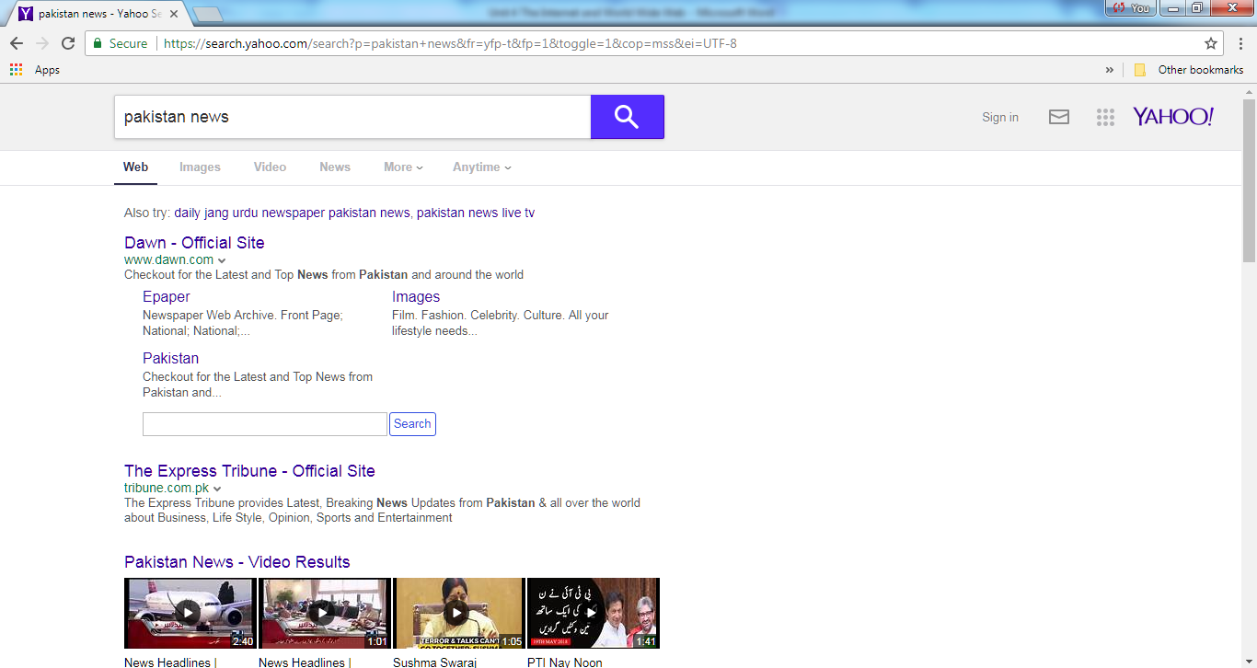 **Figure 5.2.4 (e) List of related results**

**5.2.5 Online Maps**

Online map services can be used to get directions or search for a particular address in a given location. [Google Maps](http://maps.google.com/), Bing maps, Wikimapia, MapQuest are popular online map services.

* + - **Using Google Maps**

You can search for all kinds of things, like post offices, cinemas, bus stops, street names, or even your school using Google Maps.

* Open your web browser and type <https://www.google.com/maps> which is the address of Google maps.

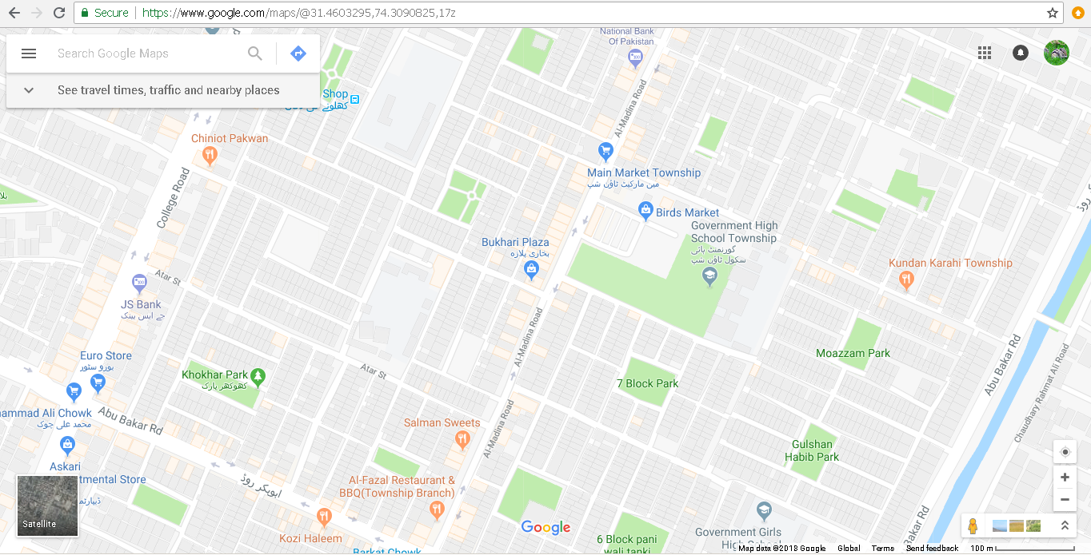

**Figure 5.2.5 (a) Google Maps**

* Type the name of your school in the search bar. Example “*Government high school township Lahore*”.
* Press Enter or click Search

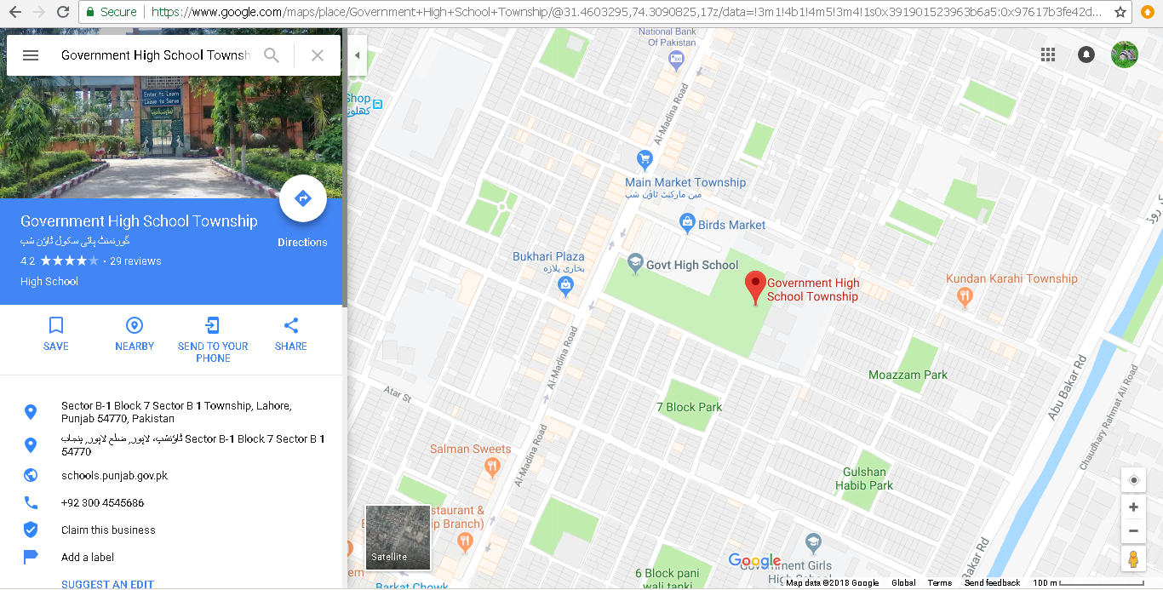

**Figure 5.2.5 (b) Search results**

* You'll see search results as red mini-pins or red dots, where mini-pins show the top results.

**5.2.6 Google Translator**

**Google Translate** is a free service developed by Google, to translate text.Google's free service instantly translates words, phrases, and web pages between English and over 100 other languages.

* Open your web browser and in the address bar type <https://translate.google.com/>
* Google translator online website will open

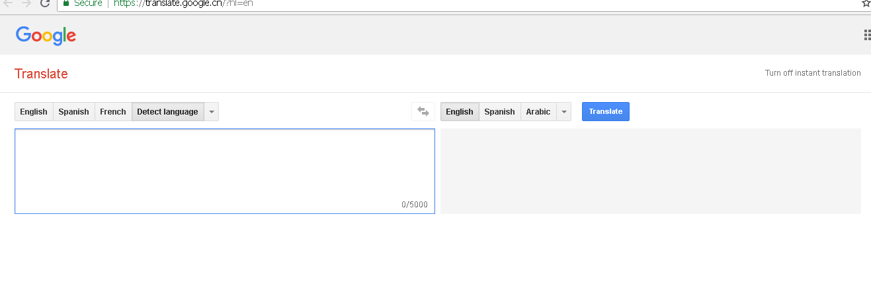

**Figure 5.2.6 (a) Google Translate**

* Select *English* and write *hello* in the left window
* Select *Arabic* above the window on right side and click on *Translate* button

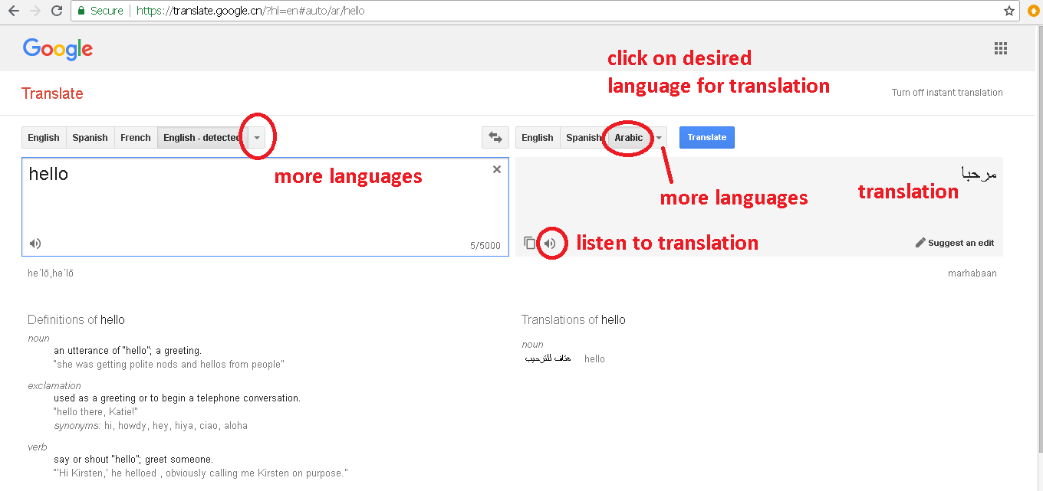

**Figure 5.2.6 (b) Using Google Translate**

# 5.3 Introduction to Email

**5.3.1 Definitions**

* **E-Mail**

Email is short for electronic mail. Similar to a letter, it is sent via the internet to a recipient. An email address is required to receive email, and that address is unique to the user. Some people use internet-based applications and some use programs on their computer to access and store emails.

**Key benefits and features of using email**

* + It is quick – your recipient receives your email as soon as they go online and collect their mail.
  + It is secure.
  + It is free.
  + Photos, documents and other files can be attached to an email, so that more information can be shared.
  + One email can be sent to more than one recipient at a time.
* **Account**

An **Email Account** acts as a virtual address for Email Messages. It is provided to you by your Email Account Provider (in most cases your Internet Service Provider) and contains information about your Username, Email Account Provider, Password and Email Settings.

* **Username and Password**

A **username** is a name that uniquely identifies someone on a computer system. For example, a computer may be setup with multiple accounts, with different usernames for each account. Many websites allow users to choose a username so that they can customize their settings or set up an online account. E-mail services, such as Hotmail require users to choose a username in order to use the service.

A username is almost always paired with a [password](https://techterms.com/definition/password). This username/password combination is referred to as a [**login**](https://techterms.com/definition/login), and is often required for users to log in to websites. A **password** is a string of characters used to verify the identity of a user. Passwords can vary in length and can contain letters, numbers and special [characters](https://whatis.techtarget.com/definition/character). Once you have logged in, your username may appear on the screen, but your password is kept secret. By keeping your password private, you can create secure accounts for various websites.

**5.3.2 Gmail**

**Gmail** is a free [email](https://www.webopedia.com/TERM/E/e_mail.html) ([Webmail](https://www.webopedia.com/TERM/W/Webmail.html)) service, which is accessible from a Web browser anywhere in the world so long as an Internet connection is present.

You can find Gmail at [mail.google.com](http://mail.google.com/). Gmail was first introduced by Google in 2004.

Most email services offer some sort of spam filtering these days, and Google's is very effective. Gmail attempts to filter advertising spam and viruses etc. Gmail became popular by giving users ample storage space. Rather than deleting old messages, you can archive them. You can also search through saved email with Google as if you were searching for web pages.

# 5.4 Send and Receive E-mail

**5.4.1 Create E-mail Account and Sign in**

To create an email account with Gmail, follow these steps:

* Open your web browser and go to [www.gmail.com](http://www.gmail.com)
* Click on *Create Account*

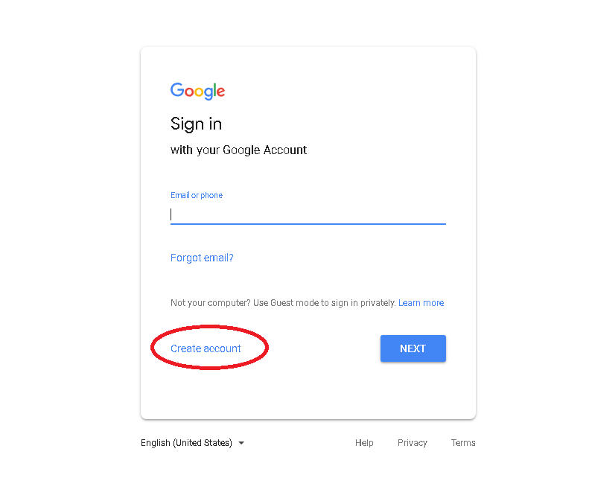

**Figure 5.4.1 (a) Create Google account**

* Fill in all the details
* Note that Gmail gives unique username/email address to each user. So if the user name that you give has already been assigned to someone else it will show an error message “That username is taken. Try another”. Keep trying other usernames until you find a unique one.

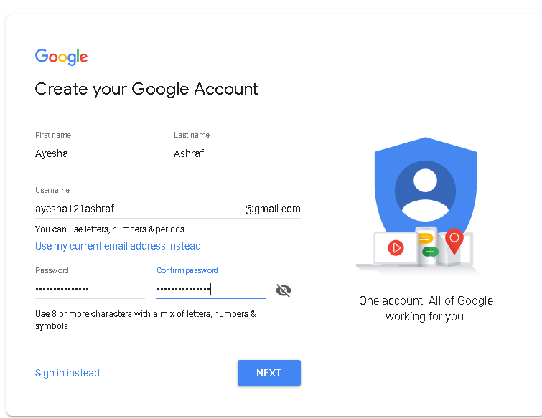

**Figure 5.4.1 (b) Fill out form-page 1**

* On the next page, leave out the options of adding phone number and recovery email address. These are for adding an additional layer of security to your email account. You can always add them later on.

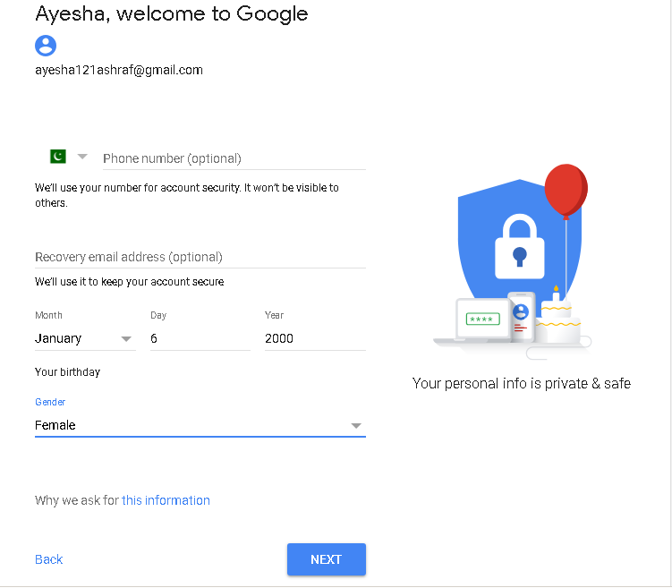

**Figure 5.4.1 (c) Fill out form – page 2**

* On the next page, read the *Terms of service* and then click on *I Agree*

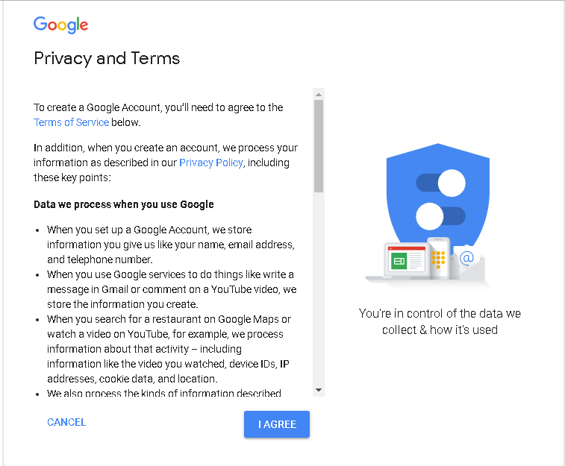

**Figure 5.4.1 (d) Terms of service**

* After this you will be automatically signed in and navigated to your account page.

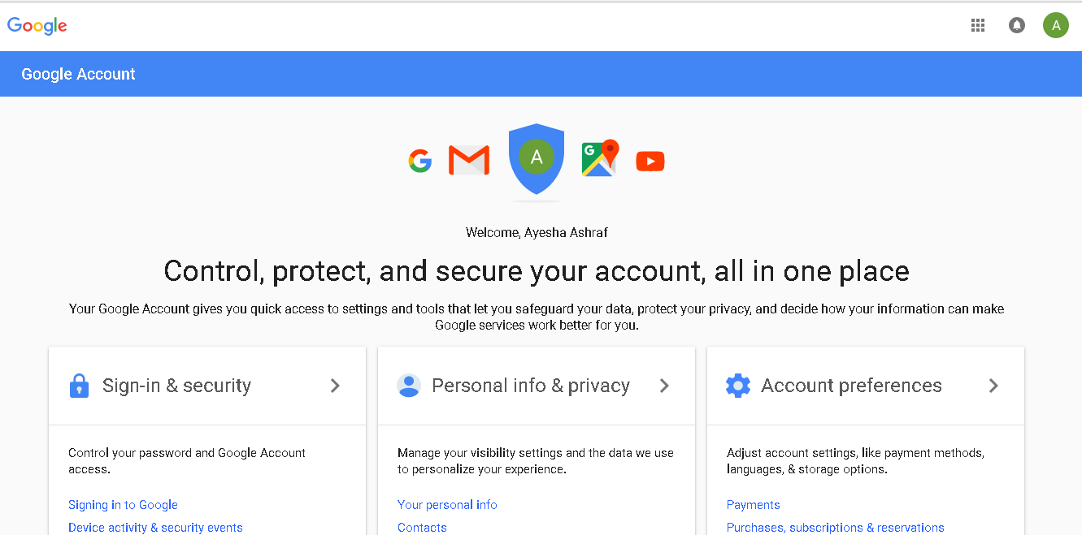

**Figure 5.4.1 (e) account main page**

To sign in to your gmail account later on follow these steps

* Through your web browser, open [www.gmail.com](http://www.gmail.com)
* Enter your username and password and click *NEXT*

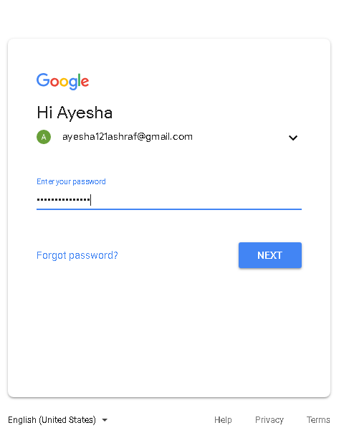

**Figure 5.4.1 (f) Sign in to your account**

* You will be redirected to your account page

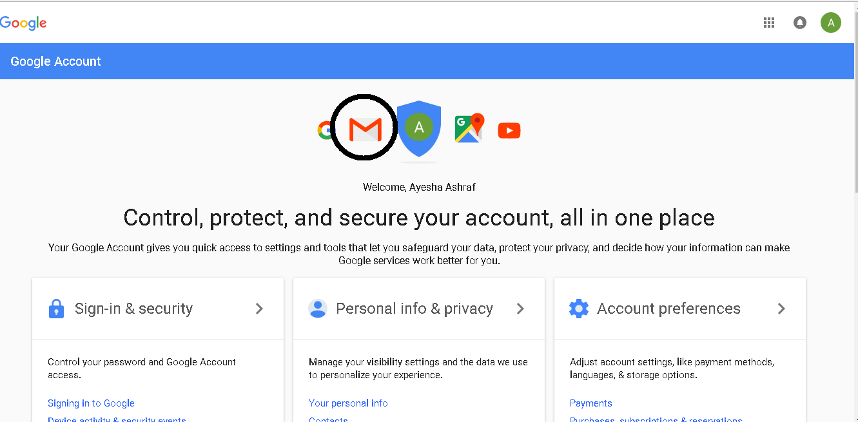

**Figure 5.4.1 (g) Open gmail**

* + Click on the gmail icon highlighted in black to go to your gmail inbox

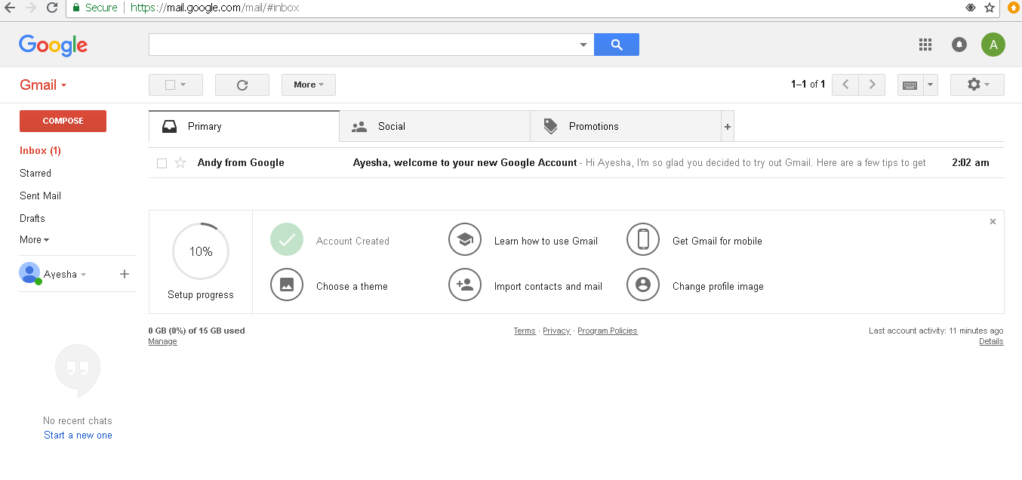

**Figure 5.4.1 (h) Gmail inbox**

**5.4.2 Important Fields**

Before writing emails there are some important terms that you should be familiar with.

**TO:**

The field labeled as ***TO****:* requires the email address of the primary receiver who you want to send email to. This field must be filled.

**Subject:**

In the **subject:** field you can add the subject of your email which should reflect the content of the email that your are sending. Filling this field is optional but if you are sending out an email without any subject gmail reminds you that you have not written any subject for your email and asks if you are sure about sending an email without a subject.

**CC:**

**CC:** is the abbreviation for Carbon Copy. This means add carbon copy, or copy this letter to the following addresses. Email addresses listed here will receive a copy of the email that you sent to the people listed in the To: field.

**Attach File:**

You can add attachments, like files or photos, to your emails and send them to your contacts.

TheAttach button is used to attach files. On clicking the attachment button a pop up window will open and you can browse through your computer to select the file you want to send. You can send up to 25 MB in attachments. If you have more than one attachment, they cannot add up to more than 25 MB.

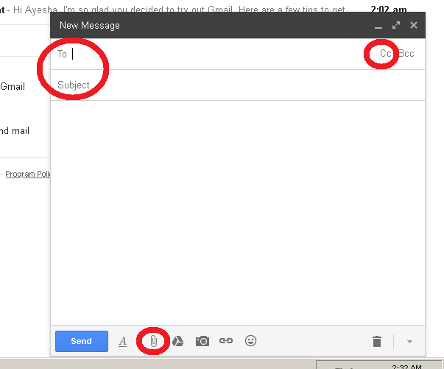

**Figure 5.4.2 Important fields**

DO YOU KNOW?

**Bcc** stands for blind carbon copy which is similar to that of **Cc** except that the Email address of the recipients specified in this field do not appear in the received message header and the recipients in the **To** or **Cc** fields will not know that a copy is sent to these address. 

.

**5.4.3 Compose and Send Email**

To compose an email, follow these steps:

* In the left side of you gmail inbox there is a red button highlighted as *compose*

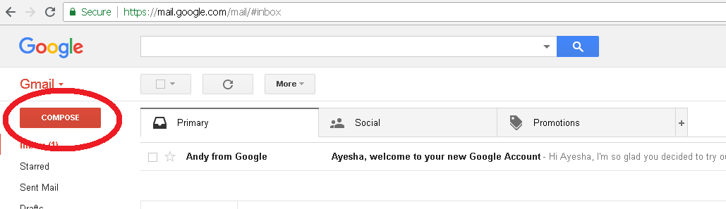

**Figure 5.4.3 (a) Compose**

* Click on *compose* button
* On clicking this button a new window will pop up for writing your email message

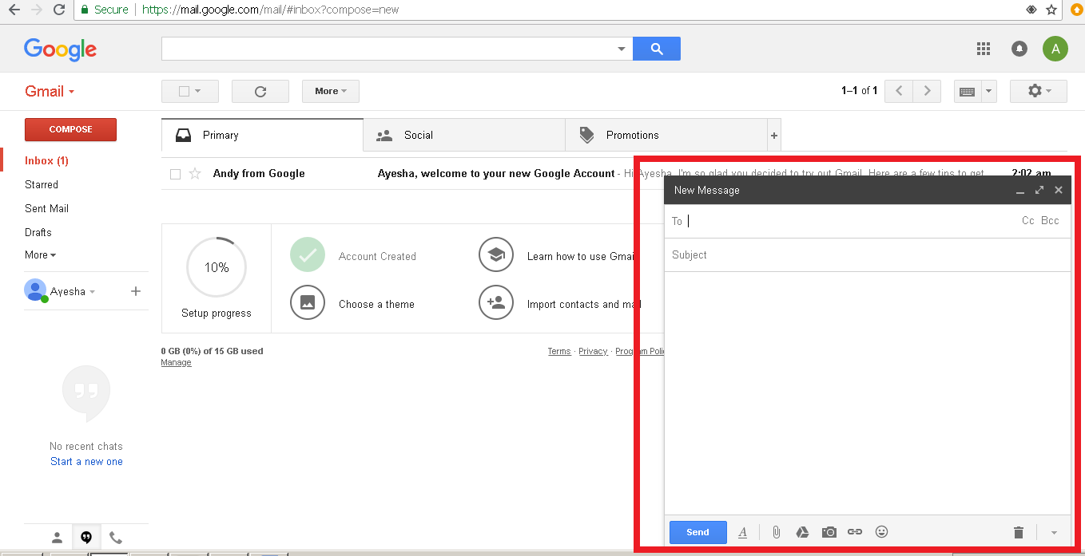

**Figure 5.4.3 (b) Compose email window**

* In the *TO:* field, write the newly created email address of your friend.
* CC: your teacher so that she can get a copy of your email as well.

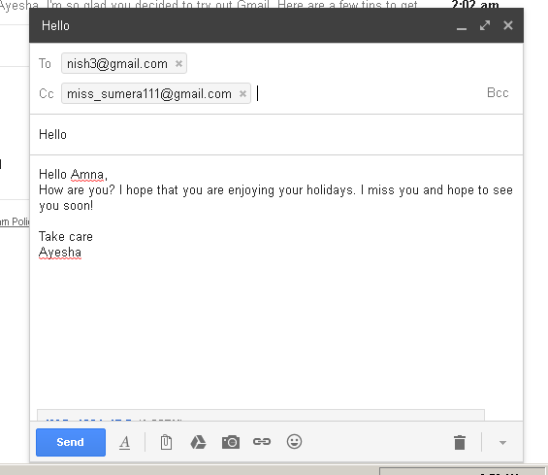

**Figure 5.4.3 (c) Fill TO: and CC: fields**

* Write whatever you want to write to your friend in the email and give it an appropriate subject.
* You can also attach a picture of yourself to send to your friend

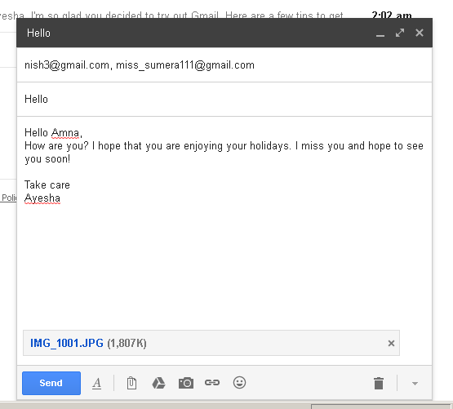

**Figure 5.4.3 (d) Attach a file**

* + Click on *Send* button to send your email.

**5.4.4 Using Gmail Folders**

Gmail keeps all your email organized by keeping it in specific folders. These folders can be accessed through the left pane on your screen under the *compose* button:

**Inbox**

This folder contains all the email that you receive from your contacts or acquaintances. All your email except spam and fraud email is kept here. Gmail can recognize spam emails and keeps them in separate folder for spam. All rest of the important email is kept in the inbox folder. When you open up gmail, by default *inbox* folder is opened.

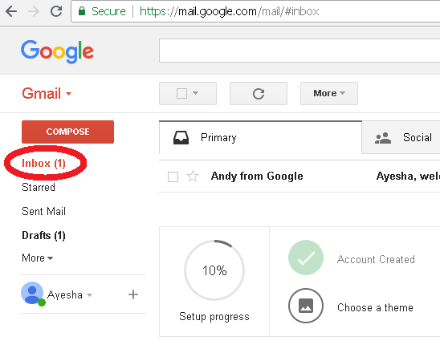

**Figure 5.4.4 (a) Inbox folder**

**Sent**

This folder contains all those emails that you have sent to your friends or family. You can see the list of your sent emails by clicking on the *Sent Mail* button in the left pane.

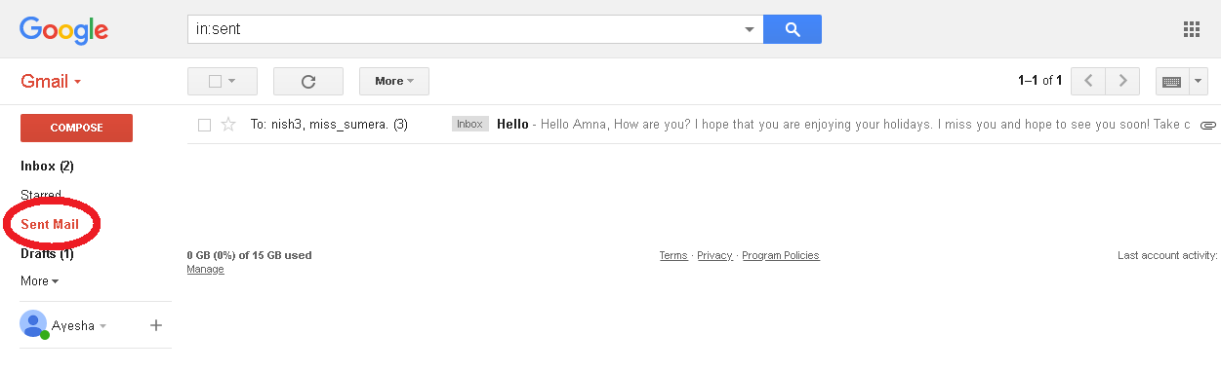

**Figure 5.4.4 (b) Sent folder**

**Drafts**

As you compose an email, [Gmail](https://www.lifewire.com/gmail-review-1171846) saves it automatically and frequently as a draft, which prevents accidental data loss when something causes your browser to hang up. **Drafts** folder will have all those email messages that you wrote but did not send due to some reason. Once you send a draft it will be removed from the *Drafts* folder and moved to the *Sent* folder.

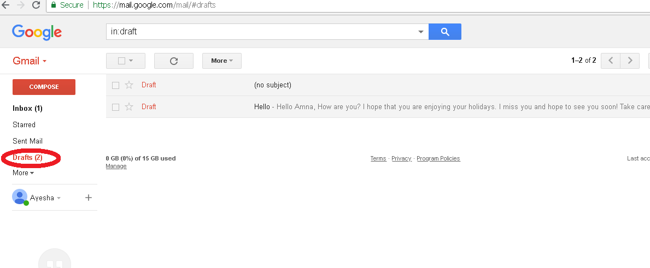

**Figure 5.4.4 (c) Drafts folder**

**5.4.5 Check and Reply Email**

* To check your email simply sign in to your gmail account.
* This will take you to your inbox folder.
* Inbox folder will show all the read as well as unread messages

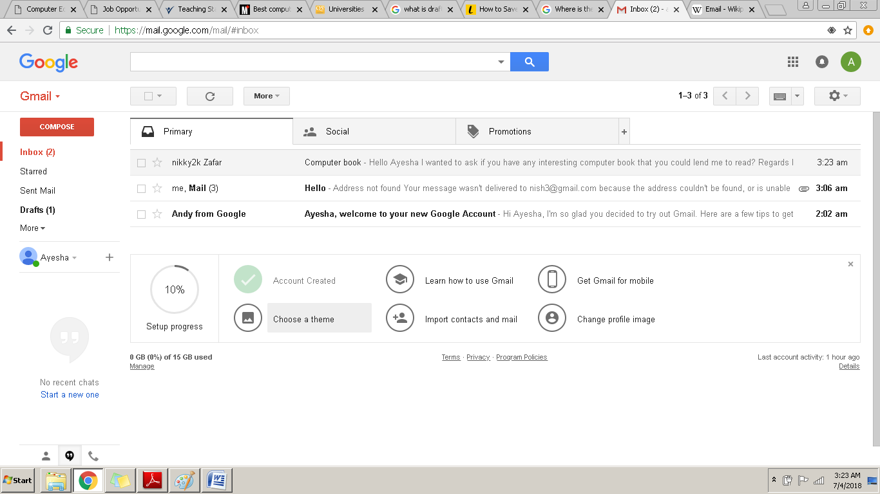

**Figure 5.4.5 (a) Check email**

* Read messages are highlighted in light blue whereas unread messages are highlighted in white
* Click on the email message that you want to read

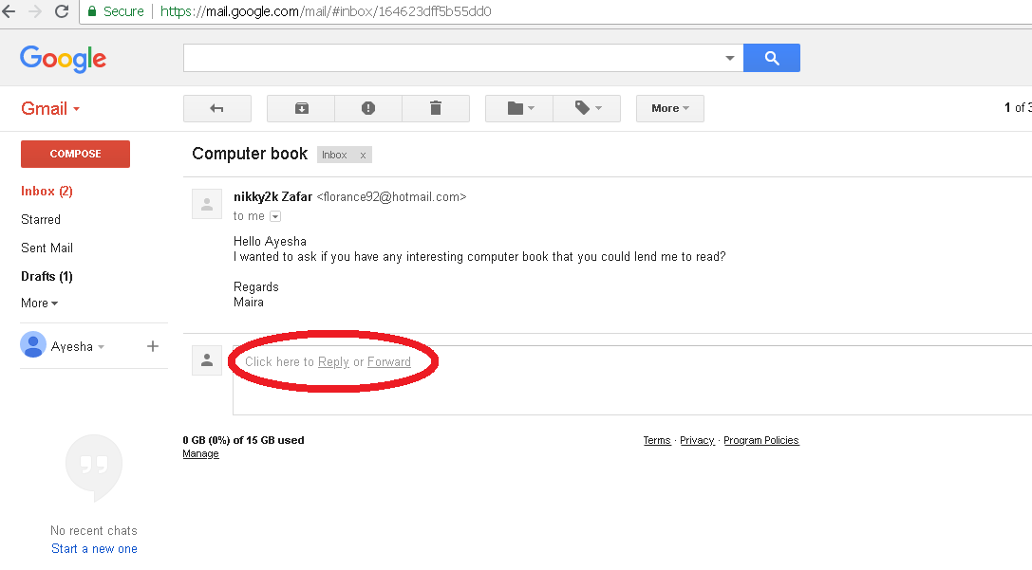

**Figure 5.4.5 (b) Reply option**

* Below the message there is an option to reply back. Click on *reply*
* A new window will open up under that message.

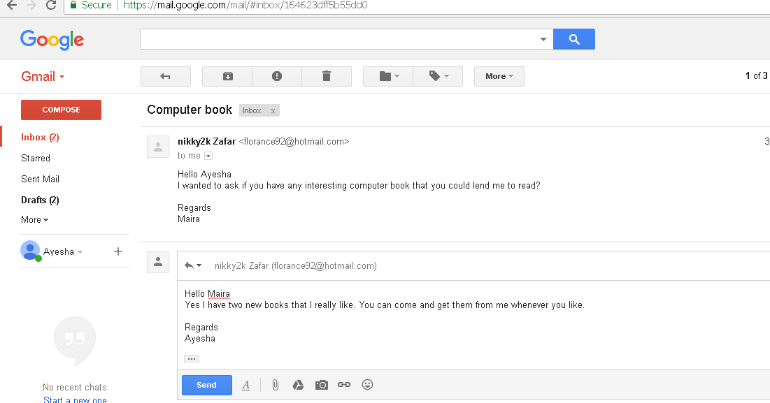

**Figure 5.4.5 (c) Reply to email**

* Type your reply here and click on send

**5.4.6 Sign Out**

Signing out of your account is very important specially if you are checking your email on a public computer or a public network. Hackers can get into your account and steal sensitive information. To avoid this, always sign out of your email account after you are done with your work.

* Click on the icon at the top right corner of your screen
* A short pop up window will open up with basic information about your account

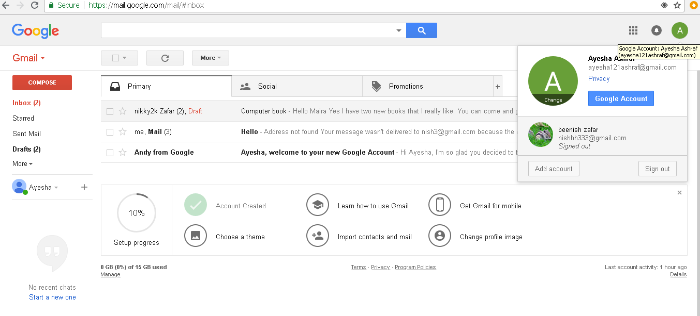

**Figure 5.4.6 (a) Sign out option**

* Click on the *sign out* button at the bottom right corner of that pop-up window

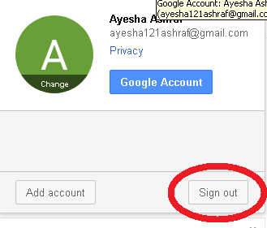

**Figure 5.4.6 (b) Sign out button**

* You will be again redirected to the main log in page for the next user to sign in to their account.

SUMMARY

* **Internet** is a global network of computer networks.
* A **network** is a system of interconnected computers that communicate with one another and share application, data and hardware components.
* **Dial-up connection** is a technology that helps a user to connect to the internet using standard phone lines.
* **DSL** is a high speed internet technology that runs over standard phone lines
* **Cable modem service** is a technology that helps users in connecting to the internet using their cable TV wire
* Satellite accesses the internet via a satellite in Earth’s orbit.
* The newest broadband service is **fiber-optic**, which is the fastest Internet connection thus far.
* **Wireless** or **Wi-Fi** does not use telephone lines or cables to connect to the internet. Instead, it uses radio frequency.
* **Cellular technology** provides wireless Internet access through cell phones.
* A **modem** is a device which is used to connect and communicate with other computers.
* A company that provides an internet connection is known as **Internet Service Provider (ISP)**.
* The **World Wide Web** is part of the Internet. It is a collection of millions of pages of information. This information can include texts, pictures, animations, sounds and videos.
* **Web page** is a document available on World Wide Web.
* A **website** is a collection of related web pages.
* **URL (Uniform Resource Locator)** is the address of a webpage on the internet.
* **Web Browser** is a software that is used to access the World Wide Web.
* **Search Engine** is a program that is used to find web pages and websites on the internet.
* Online map services can be used to get directions or search for a particular address in a given location.
* **Google Translate** is a free service developed by Google, to translate text.
* Email is short for electronic mail. Similar to a letter, it is sent via the internet to a recipient.
* An **Email Account** acts as a virtual address for Email Messages.
* A **username** is a name that uniquely identifies someone on a computer system.
* A **password** is a string of characters used to verify the identity of a user.
* **Gmail** is a free email (Webmail) service, which is accessible from a Web browser anywhere in the world so long as an Internet connection is present.
* The field labeled as ***TO****:* requires the email address of the primary receiver who you want to send email to. This field must be filled.
* In the **subject:** field you can add the subject of your email which should reflect the content of the email that your are sending.
* **CC:** is the abbreviation for Carbon Copy. This means add carbon copy, or copy this letter to the following addresses.
* You can add attachments, like files or photos, to your emails and send them to your contacts.
* **Inbox** folder contains all the email that you receive from your contacts or acquaintances.
* **Sent** folder contains all those emails that you have sent to your friends or family.
* **Drafts** folder will have all those email messages that you wrote but did not send due to some reason.
* Signing out of your account is very important specially if you are checking your mail on a public computer or a public network.

EXERCISE

## Q.1 Tick the right choice

1. __________ is a global network of computer networks.

a) Internet b)Intranet c) network d)Group

1. More than _________ people around the world are using the internet.

a) 8 billion b) 6 billion c) 4 billion d) 5 billion

1. _____________ is a slow speed and inexpensive technology.

a) Wifi b) dial-up connection c) DSL d) Fiber-optic connection

1. A **________** is a device which is used to connect and communicate with other computers.

a) modem b) telephone c) fax machine d) printer

1. Which of the following is an Internet Service Provider (ISP)?

a) PTBB b)PTCL c)PEMRA d) WAPDA

1. The software used to access and view web pages is called ________

a)Web server b)Web browser c) Web explorer d)Web linker

1. WWW stands for _________________

a)World Wide West b)World With Web c)World Wide Web d)World Wide Work

1. ______________ is the address of a webpage on the internet

a) UOL b)UCL c)UDL d)URL

1. ______________ services can be used to get directions or search for a particular address in a given location.

a) online map b) online directions c) online navigation

d) online guidance

1. Search Engines use a program **__________** which reads the documents and creates an index based on the words contained in each document.

a) spider b) scheduler c) indexer d) sorter

1. The home page of Google Chrome is set to __________

a) MSN b) ASK.com c) Google search d)Google Scholar

1. ____________ is a search engine

a)Bing b)typing master c)wikihow d)w3schools

1. Safari is a ___________

a) web browser b) website c) search engine d) program

1. A ___________is a string of characters used to verify the identity of a user

a) username b) password c) email address d)login ID

1. **___________** is a free email (Webmail) service, which is accessible from a Web browser anywhere in the world

a) Bing b)Google Translate c)Gmail d)Google map

## Q.2 Fill in the blanks

1. Internet was evolved in 1969, under the project called _________
2. A **_________** is a system of interconnected computers that communicate with one another and share application, data and hardware components.
3. **_________________** is a free service developed by Google, to translate text.
4. NR3C is a law enforcement agency dedicated to fight _________ in Pakistan.
5. **______** is a term that describes a 3rd generation cellular network.
6. An **______________** is a network device that is contained on an expansion board that plugs into the motherboard.
7. A **___________** is a software which is used to access and view different websites.
8. The World Wide Web was invented by ______________ in 1989.
9. In Google maps,You will see search results as __________ or ___________
10. _____________ is required to receive email, and that address is unique to the user.
11. Web search engines work with the help of a program **_________** which fetches as many documents as possible.
12. **CC:** is the abbreviation for ____________

## Q.3 Define the following

1)Internet 2)World Wide Web 3) URL 4)Web browser 5) Search engine 6)ISP 7) CC: field 8)inbox folder 9) sent folder 10) drafts folder

## Q.4 Give brief answers to the following questions

1. Write down steps to find your home in Google maps.
2. What is an email? write down its key benefits.
3. What are the requirements for connecting to the internet?
4. Write down steps to compose and send email.
5. Write down the steps for accessing different web pages using Internet explorer.
6. Define and explain a search engine.
7. Write down the steps for searching “Pakistan cricket” on Yahoo search engine.
8. Define modem and explain its types.
9. Define and explain broadband internet service.
10. Write names and URLs of five different search engines.

## Q.5 Differentiate between the following

1)internet and world wide web

2)username and password

3)telephone modem and cable modem

4)web browser and search engine

5)sent and drafts folder

## Q.7 Label the following diagram

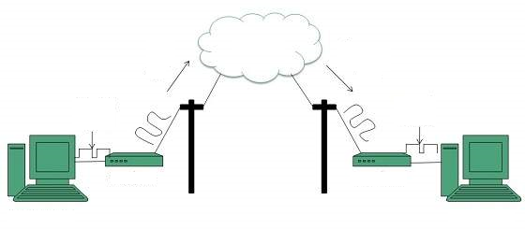

## Q.8 Match column A with column B and write the matching pairs in column C

|  |  |  |
| --- | --- | --- |
| Column A | Column B | Column C |
| 1. ARPANET | a) fastest internet connection |  |
| 1. network | b) Google Search |  |
| 1. Email | c)World Wide Web |  |
| 1. DSL | d)system of interconnected computers |  |
| 1. Fibre optic | e) Web browser |  |
| 1. Qubee | f) Advanced Research Projects Agency Network |  |
| 1. Opera | g) Digital Subscriber Line |  |
| 1. URL | h) internet service |  |
| 1. Google Chrome | i) ISP |  |
| 1. WWW | j) Uniform Resource Locator |  |

**Lab Activity 1**

1. With the help of your teacher, find out the type of modem and connection used to provide internet in your computer lab.
2. What is the name of your ISP?

**Lab Activity 2**

* Open your web browser
* Open the website for scratch programming. Its URL is <https://scratch.mit.edu/>
* Click and open any “hyperlink”

**Lab Activity 3**

* Open your web browser
* Open “Yahoo” search engine
* Type “top 5 computer games” in the search bar
* Click on the first link that appears on top of the results
* Make a list of top 5 computer games on a paper

**Lab Activity 4**

* Open your web browser
* Open the following websites by writing their URLs in address bar one by one.
* Look at the homepage of each website

1. <https://www.mint.com/>
2. <https://www.dropbox.com/>
3. <https://www.amazon.com/>
4. <https://www.daraz.pk/>

**Lab Activity 5**

* Open your web browser
* Open the website for Google Maps <https://www.google.com/maps>
* Search for your favorite restaurant
* Click on the *nearby* button to see similar restaurants that are open around your favorite restaurant

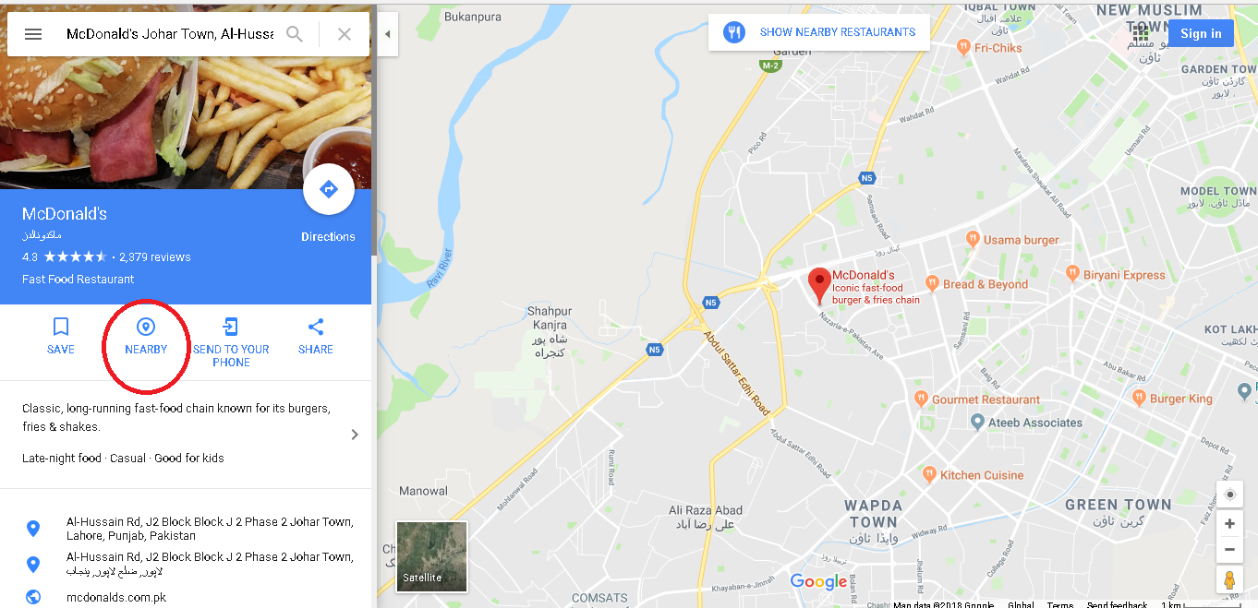

* + Your favorite restaurant will be highlighted as a red pin while nearby restaurants will be highlighted as orange pins.

**Lab Activity 6**

* Open your web browser
* Open Google translate <https://translate.google.com/>
* Write “*where are you?”* in the left window
* Select language *Urdu* above the right window
* Click on *Translate* button

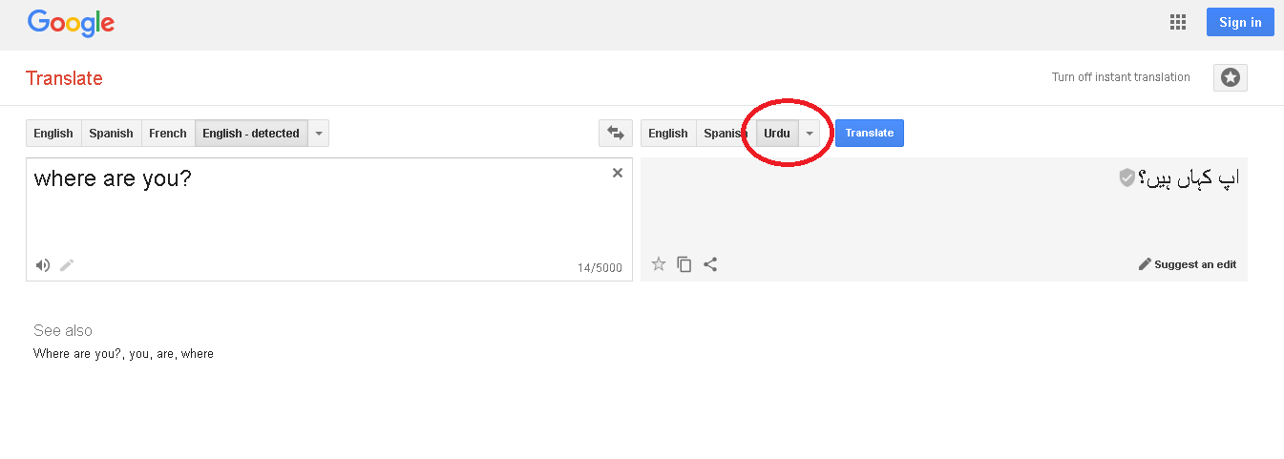

**Lab Activity 7**

* Create an email account following the steps given in the chapter
* Compose and send an email to your friend
* Attach a picture of your favorite cartoon character
* CC: to your teacher
* Ask your friend to perform the same task
* Check your email inbox folder
* You should have received an email from your friend
* Send a reply to that email